

INDIVIDUAL ASSIGNMENT

**TECHNOLOGY PARK MALAYSIA AICT003-4-2-NWN**

**NETWORKS AND NETWORKING**

**UCDF1905ICT(SE)**

**/UCDF1905ICT/UCDF1905ICT(DI)/UCDF1905ITR**

HAND OUT DATE: Week 4: 12th August 2020 HAND IN DATE: Week 14: 28th October 2020 Weightage: 50%

Online Submission Time before = 11: 59 PM

**NAME: LEE JUN LAM (TP055697)**

**INSTRUCTIONS TO CANDIDATES:**

1. Students are advised to underpin their answers with the use of references (cited using the Harvard name system of Referencing)
2. Late submission will be awarded zero (0) unless Extenuating circumstances (EC) are upheld.
3. Cases of plagiarism will be penalized.

Table of Contents

1.0 Introduction 3

2.0 Floor Plan 4

2.1 Ground Floor 4

2.1 First Floor 5

3.0 Network Topology 6

3.1 Local Area Network (LAN) 6

3.2 Wide Area Network (WAN) 7

4.0 IP Addressing 8

5.0 Configuration Techniques 10

6.0 Conclusion 13

7.0 References 13

7.1 References 13

# Introduction

This assignment for the module of Networks and Networking requires students to form a local area network design and configuration using simulation tool which is Cisco Packet Tracer for the given scenario and justify the topology and IP addressing plan based on the network design. The main aim of the assignment is to provide the readers with a clear idea about the topic of given scenario and to provide a fast and reliable connection without any budget constraints. Students are required to apply their conceptual knowledge from the module on various networking technologies and practical skills from Cisco Packet Tracer on configuration techniques in order to develop a floor plan and network diagram with strong justification to support their design concept. According to the scenario given, there will be a direct Wide Area Network connection (WAN) established from the MT center Local Area Network (LAN) to the Server Farm where all the servers and cloud facilities are hosted. Not only that, various wired connection devices and wireless connection devices should be included in the tuition center. As an example, wired connection such as tuition center PC that connected statically while wireless connection devices such as laptop due to student will possibly bring their personal device from one location to another location in the tuition center. Thus, various consideration needs to be figure out in order to design an effective network.

# Floor Plan

## 2.1 Ground Floor

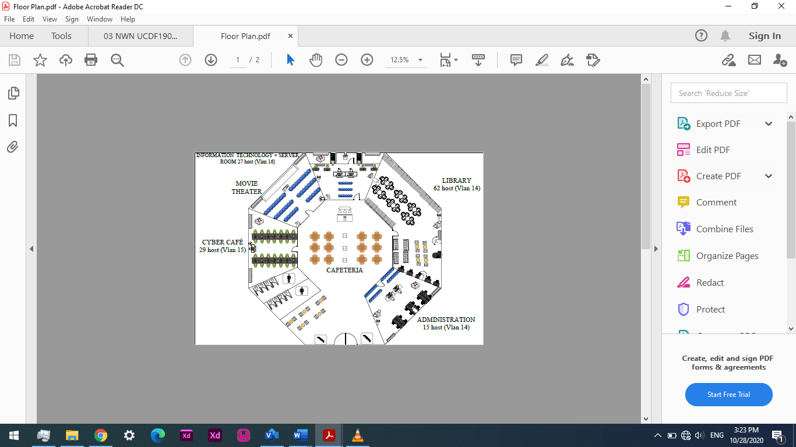 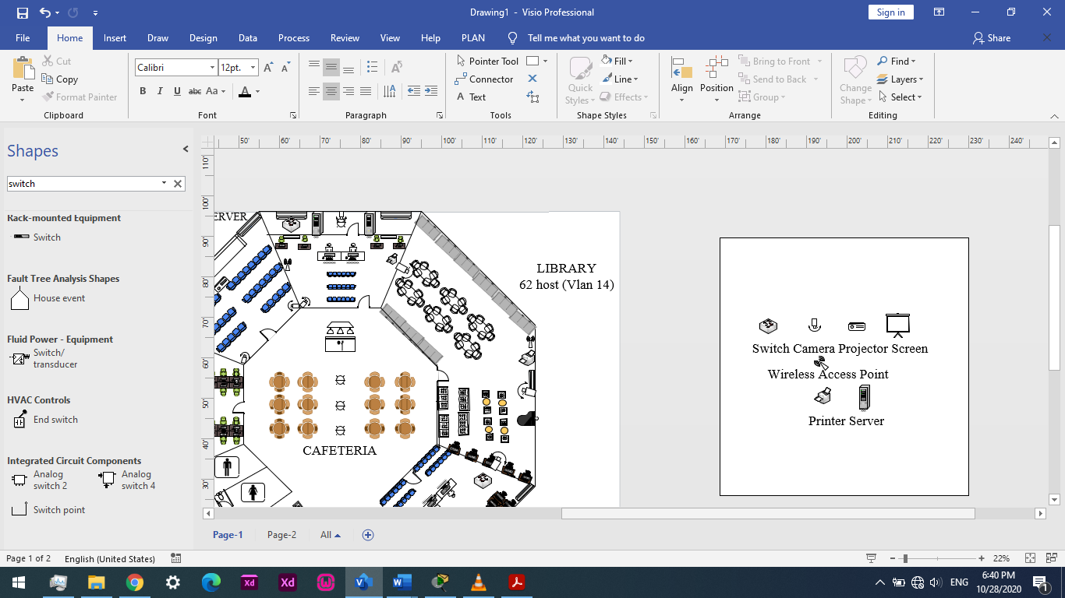

Figure 1: MY Tutor Tuition Center Ground Floor’s Floor Plan

Figure 1 above representing MY Tutor tuition center ground floor’s floor plan contains seven different sections. The seven sections are Cafeteria, Administration Department, Library, Information Technology Department, Server, Movie Theater and Cyber Café. Administration Department and Library shares the same switch as they location are nearby to each other and Administration Department has lesser user while Information Technology Department and Cyber Cafe has its own switch for connectivity to the network devices, end devices. Each section except Cafeteria also has its own access point with several SSID for restrictions for particular users alongside Closed-circuit Television (CCTV) to monitor the tuition center’s security and student activities. A printer also provided in Administrations Department, Library and Information Technology Department for printing purposes. Meanwhile for the computers, and projectors, these devices are being allocated based on the section requirements. A larger men room and ladies room also provided for people that visits the tuition center to be able to bladder.

## 2.1 First Floor

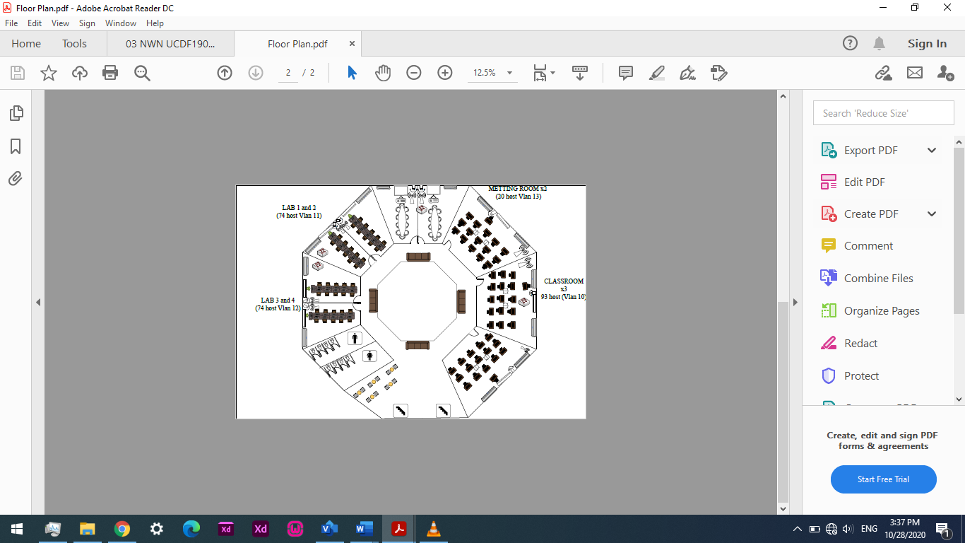 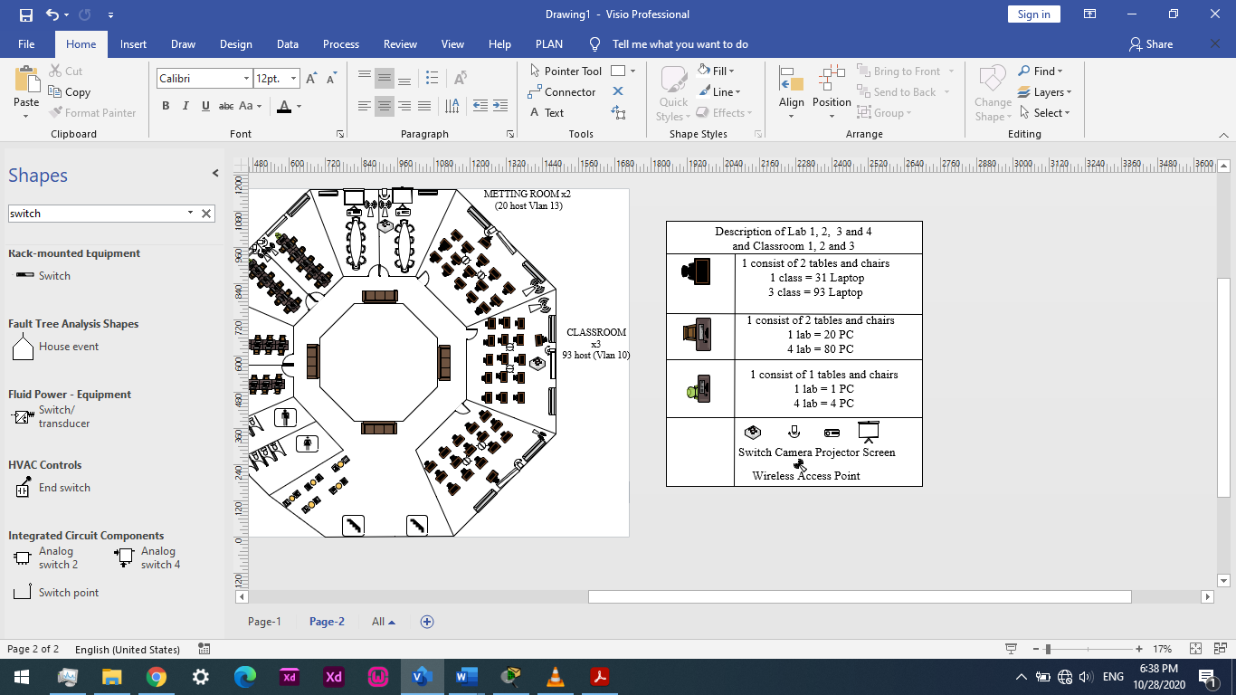

Figure 2: MY Tutor Tuition Center First Floor’s Floor Plan

The first floor from the Figure 2 is rather simple as there are three Classroom provided with three access point for student to use their laptop. The are also four Lab provided with twenty students computers and one tutor computer, four access point has been provided in four labs in case any computers malfunction and student can use their laptop. Two Meeting rooms also allocated with access point and projector for conference purposes. Each of the access points has its own SSIDs for connectivity of different users such as tutor and student. Last but not least, first floor also provided with large washroom and security cameras in Classrooms, Labs and Meeting rooms.

# 3.0 Network Topology

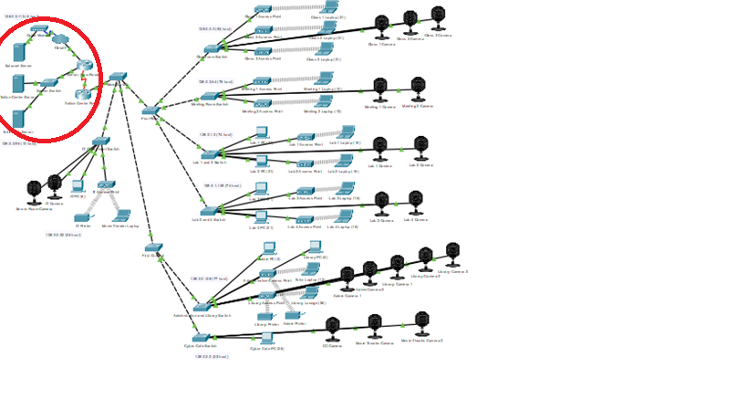

Figure 3: Showing The Network Topology (Red Circle is WAN while no circle is LAN)

## 3.1 Local Area Network (LAN)

According to the Figure 3 shown above, the type of network topology that applied in MY Tutor tuition center is star topology as it is it is high-performing as no data collisions can occur and very reliable. To further illustrating the situation, all the others device will continue to work if one cable or device fails due to the usage of Virtual Local Area Network (VLAN). First of all, there are three switches which are first floor switch, ground floor switch and IT Department switch connected to main switch which play the roles as the hub to the two switches in the tuition center. From the first-floor switch and ground floor switch, there are several switches further connected to both of the switch to various section. These switches that further connected plays an important role beside from bridge with multiple ports which helps to process and route packets at data link layer of the OSI reference model, it  reduce the incidence of collisions and decrease the number of network resources wasted by acting as LAN segments with the usage of VLAN database and VLAN access point that has configure into the particular port (solarwindsmsp, 2019). As an example, if the classroom switch is malfunction, the lab and meeting does not get affected and the classroom computer and laptop can ping to lab switch rather than ground floor switch to continue use the network as data packets sent from a device in a section are transferred by a bridge or switch, which will not forward collisions but will send on broadcasts to every network device. Another situation is when ground floor switch is malfunction, the first-floor switch will serve as the backup as it also connected to the port can be connected directly to the Main Switch. However, if both switches are down, IT Department switch will serve as the final line which explains why IT Department switch is separate from the first-floor switch and ground floor switch. Thus, the VLAN usage offers at least 3 layers of backups in case any switch is malfunction. It is important to configure Inter VLAN routing to ensure different VLAN can ping with each other. However, it will only act as a short fix and any switch malfunction occur must be solved as fast as possible. It is advice to examine main switch condition once a while as if the network is totally down if main switch is malfunction. Another reason that star topology is chosen because it is easy to manage and maintain the network and problems identification is simpler as the cable failure only affect a single user and extend the network without disturbing to the entire network and the network provide high speed data transfer (Jahejo, n.d.). However, it required a lot cable and too much cable and switch use will reduce the latency of network, thus the port is applied with gigabit ethernet to reduce the problem occur even though it is higher price because for long term usage.

## 3.2 Wide Area Network (WAN)

According to the red circle shown in the Figure 3 above, star topology is used for the Wide Area Network. Unlike Mesh topology, star topology does not allow direct communication between devices, a device must have to communicate through hub and it provides higher data transfer speed. As an evidence, if tuition center requires data from the server, the signal must send through the tuition center router and data from the server must send data through server farm router. Due to the Wide Area Network only has two routers, lesser amount of cables required because each device just needs to be connected with the hub only. However, the Hub requires more resources and regular maintenance because it is the central system of star topology and if one of the hubs is malfunction, the network is considered down. However, fault is easy to identify as troubleshooting is relatively easy after the hub is down (SINGH, 2020).

# 4.0 IP Addressing

|  |  |  |  |  |  |  |  |  |
| --- | --- | --- | --- | --- | --- | --- | --- | --- |
| Subnet | No of Host | Bits borrowed (2n) | Vlan | Subnet Mask | Network Address | Broadcast Address | Range of usable IP | Excluded  IP |
| Classroom | 93 | 27 = 128 | 10 | 255.255.255.128 | 128.0.0.0 | 128.0.0.127 | 128.0.0.1-128.0.0.126 | 128.0.0.1 |
| Admin and Library | 77 | 27 = 128 | 14 | 255.255.255.128 | 128.0.0.128 | 128.0.0.255 | 128.0.0.129-  128.0.0.254 | 128.0.0.129-128.0.0.136 |
| Lab 1 and 2 | 74 | 27 = 128 | 11 | 255.255.255.128 | 128.0.1.0 | 128.0.1.127 | 128.0.1.1-128.0.1.126 | 128.0.1.1--128.0.1.43 |
| Lab 3 and 4 | 74 | 27 = 128 | 12 | 255.255.255.128 | 128.0.1.128 | 128.0.1.255 | 128.0.1.129-  128.0.1.254 | 128.0.1.129-  128.0.1.172 |
| CC | 29 | 25 = 32 | 15 | 255.255.255.224 | 128.0.2.0 | 128.0.2.31 | 128.0.2.1-128.0.2.30 | - |
| IT | 27 | 25 = 32 | 16 | 255.255.255.224 | 128.0.2.32 | 128.0.2.63 | 128.0.2.33-  128.0.2.62 | 128.0.2.33-  128.0.2.38 |
| Meeting | 20 | 25 = 32 | 13 | 255.255.255.224 | 128.0.2.64 | 128.0.2.95 | 128.0.2.65-128.0.2.94 | 128.0.2.65 |
| Server | 10 | 24 = 16 | - | 255.255.255.240 | 128.0.2.96 | 128.0.2.111 | 128.0.2.95-128.0.2.110 | - |
| Extranet | 5 | 23=8 | - | 255.255.255.248 | 128.0.2.112 | 128.0.2.119 | 128.0.2.113-  128.0.2.118 | - |
| S1 | 2 | 22 = 4 | - | 255.255.255.252 | 128.0.2.120 | 128.0.2.123 | 128.0.2.121-  128.0.2.122 | - |

The IP address configuration being used in configuring the Local Area Network (LAN) of MY Tutor tuition center is Classless Internet Protocol Version 4 (IPv4) with the Variable Length Subnet Mask (VLSM) with class size B. The reason why Classless Internet Protocol Version 4 (IPv4) is used because in classless routing, VLSM and CIDR (Classless Inter-Domain Routing) is supported with requires lesser bandwidth and to avoid exhaustion of IPv4 addresses by setting different number of usable IP address range based on the number of host and number of host bites borrowed. The subnet mask can be change in the topology according to the number of host bits borrowed.

Compared with FLSM, VLSM often know as subnetting a subnet is used to maximize efficiency by dividing the address space based on the subnets requirements as the FLSM can only allocates a fixed address space size for all the subnet groups. Inefficiency could happen if using FLSM in this situation and a large number of unused IP address wasted for the subnets that required a small number of hosts and significantly slowed down the consumption of IP addresses (NFWare, 2018). The maximum host for Class B is 65,536 but MY tuition center does not reach to the maximum host. Wasting of network IP addressing space can causing both technical and economic implications. On the technical side, it accelerates its exhaustion while on the economic side, it will cost a lot of price because network IP addresses are expensive. Therefore, the introduction of VLSM allowed the IP address allocation of a smaller block. The number of subnets for MY tuition center is 10 and differentiate to reduce traffic for each of the subnets and for every user in the tuition center to obtain fast connection. As an example, the highest host is Classroom subnets which is 93 host thus 128 host needs to be placed the highest position in the VLSM table. Besides that, the usage of VLSM the number of IP address needed to be allocated to each of the subnet group can be as close fit as possible.

# 5.0 Configuration Techniques

Several types of configuration techniques need to be integrated in order to implement a fast and reliable network such as VLSM, VLAN, Inter VLAN Routing, DHCP and RIP routing version 2. First of all, it is very important to have a proper planning on VLSM as it is the most crucial step in order to identify the number of subnets and arrange accordingly based on the number of hosts follow by identify the IP addresses to form maintenance, scalability and management of the networks. More importantly, it will assist in configurate DCHP to excluded several IP addresses for wired network device. The second type is VLAN. Virtual Local Area Network (VLAN) is amongst the techniques that used as it is a logical division of computer systems in a LAN (Local Area Network) that are connected to a switch by dividing broadcast domains in a LAN environment., based on their functionalities to differentiate different type of user to have different accessibility in order to for enhancing security between various departments and also for easy configuration. This is clearly highlighted through classroom computer and classroom CCTV. Even though they share the same switch, but classroom computer has its own VLAN while classroom CCTV uses IT Department VLAN in order to ensure that only IT security has full access on cameras and to prevent students misused or shut down the cameras for illegal activities. Another reason why VLAN is chosen is to reduce the amount of traffic and allows a fast connection to all the user by separating the network.

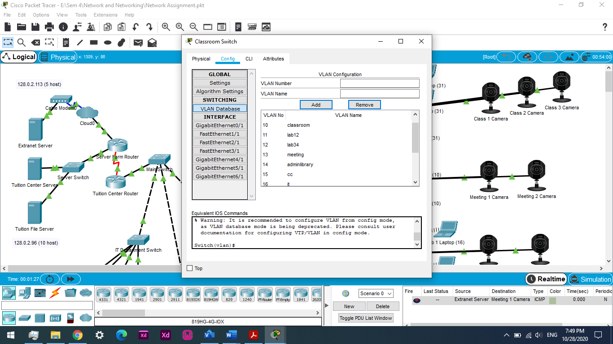(VLAN configuration)

The third technique that applied is Inter VLAN routing configuration to ensure different VLAN communicate with each other by configuring sub-interfaces have been split inside the router port that is connected to the main switch which allows each of the different VLANs to have its own default gateway. Inter VLAN routing plays another crucial role especially for wireless device such as student laptop as student will use their laptop in different sections and to reroute by the router to communicate between different VLANs. For example, students who wishes to print document in library but still connecting to class access point needs to allow their laptop communicate with the printer.

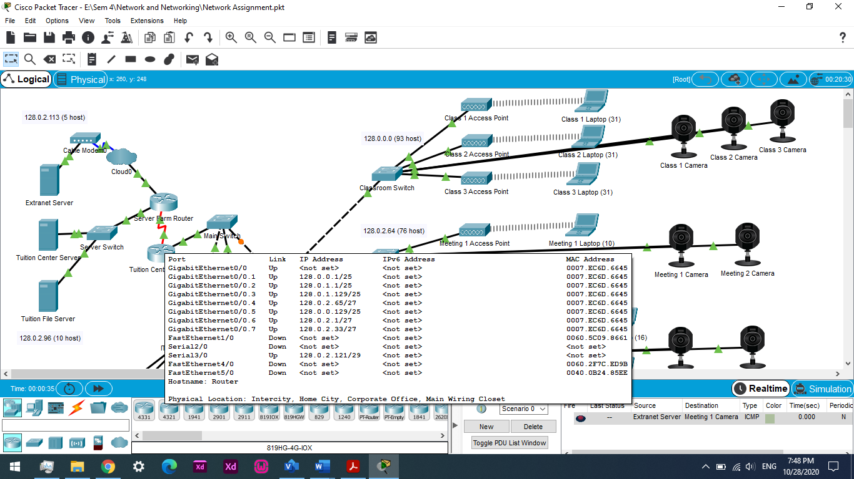(Inter Vlan Routing from Lab exercise and Result from Assignment)

The fourth technique is static and DCHP to assign IP addresses to all the devices that uses the tuition center network. Static configuration is carried out for each of the tuition center PC by manually configure the IP address in order to reduce the chances of same IP address overlap especially for cybercafé. This allows the IP address being able to be monitor and keep track on. The IT Department security of the tuition center also could keep track on the number of PCs in the particular room that have PC with static IP configuration and decided whether can increase the number of PC in the future or not. Meanwhile, DHCP is configure for wireless devices especially for laptops as the user will not stay in the same section always and connect their laptop to different access point. In fact, DHCP assigned a new IP address to allow another user to use once the IP address that have been disconnected from the last user and allowing connection to other users.

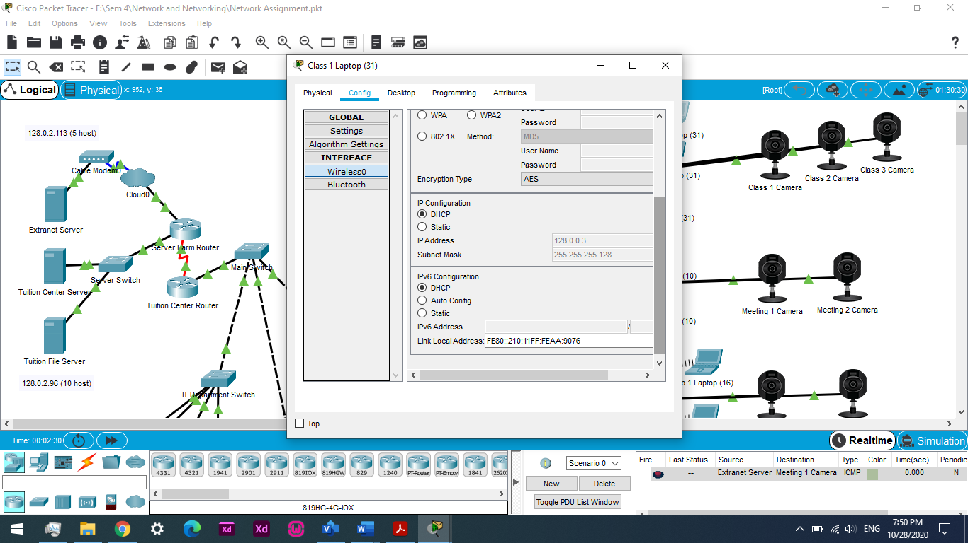(DHCP) 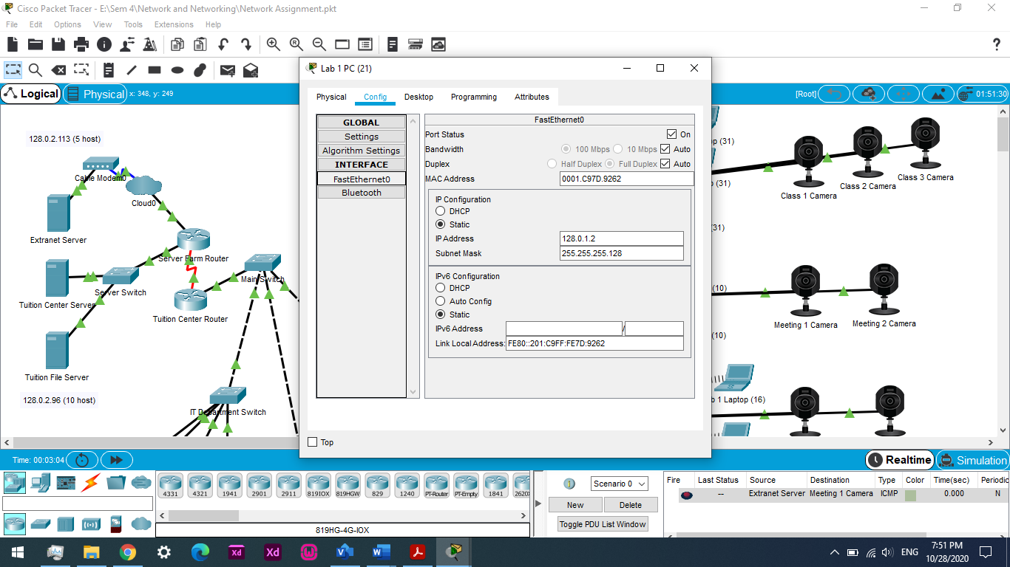(Static Configuration)

The fifth configuration technique has been applied is Routing Information Protocol Version 2 (RIPv2) in Wide Area Network as it is better compared to static routing because RIPv2 requires configure network address that has existing in the router Local Area Network while static requires configure network that not connected within the router. This can reduce chances of mistakes made as RIPv2 does not required configure next hop IP address with a no shut command. Not only that, the routers are being able to reroute if one of the route paths is malfunction.

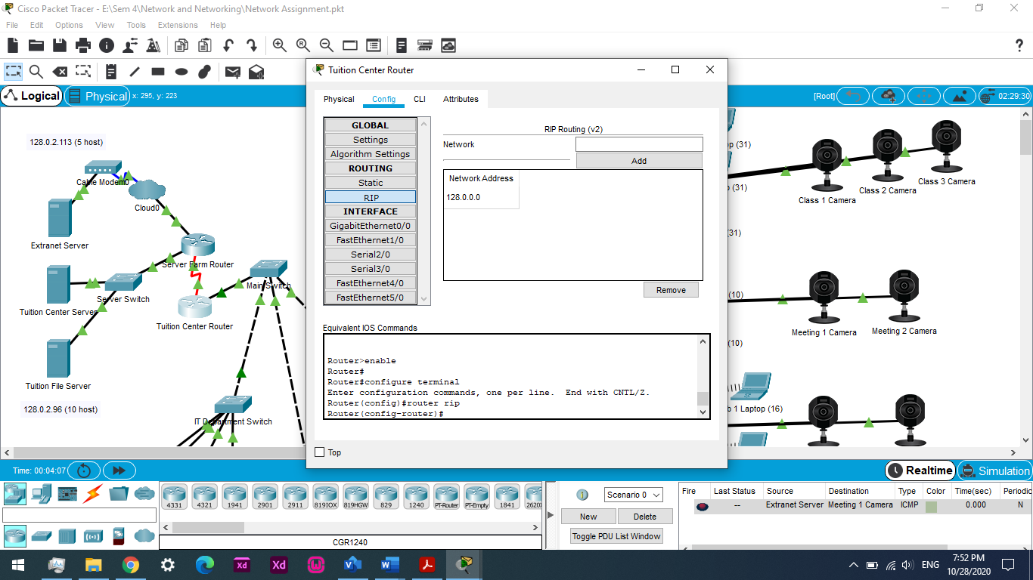(RIPv2)

Last but not least, it is very important to assign password for wireless connection especially IT Department for security measure. The password that implemented should not simply share with others specifically to avoid unknown user from being connected to the network connection.\

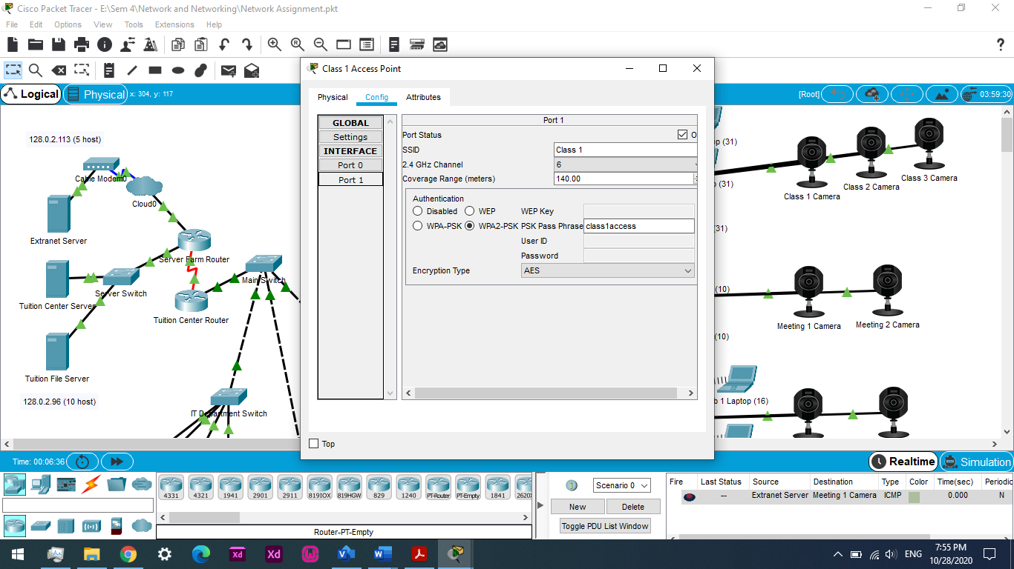(Password in Access Point)

# 6.0 Conclusion

This assignment makes me understand more and applying the knowledge from the Network and Networking module and perform calculation of VLSM accurately and able to configure of VLAN, Inter VLAN Routing, DHCP and RIP Routing Version 2. This assignment combines both theoretical and practical part of networking makes the theory part to come to sense as I need to figure out my own network topology by applying the knowledge and understand the concept how it works, why it works in particular ways, what is the outcome and how to solve the problem if unsuccessful. According to this experience, I am not only learned how to configure in Cisco Packet Tracer, but also briefly understand the network around my home.

However, the most challenging part in this assignment is requires very good planning and VLSM calculation. If there is any modification like adding new subnets, modify current subnets or miscalculate happens, majority of the configuration that has been done will gone to waste. Thus, this assignment trained me not to do things too hustle but think carefully and plan according. There is no greater weapon than a prepare mind.

# 7.0 References

# 7.1 References

Jahejo, A., n.d. *Star Topology | Advantages & Disadvantages of Star Topology.* [Online]   
Available at: https://computernetworktopology.com/star-topology-advantages-disadvantages/  
[Accessed 27 October 2020].

NFWare, 2018. *Limitations of IPv4 and IPv4 exhaustion.* [Online]   
Available at: https://nfware.com/blog-ipv4-limitations  
[Accessed 28 October 2020].

SINGH, C., 2020. *Computer Network Topology – Mesh, Star, Bus, Ring and Hybrid.* [Online]   
Available at: https://beginnersbook.com/2019/03/computer-network-topology-mesh-star-bus-ring-and-hybrid/  
[Accessed 27 October 2020].

solarwindsmsp, 2019. *How VLAN Works.* [Online]   
Available at: https://www.solarwindsmsp.com/blog/what-are-vlans  
[Accessed 27 October 2020].